The Multiple Origins of Surges in Covid-19 Epidemics

Ernie Chang

Ken Moselle

April 4, 2021

**INTRODUCTION**

In this paper, we consider the phenomena of waves and surges of population infections experienced worldwide in the present SARS-2-Cov pandemic, and show that these aggregate observations can arise from different causes, using detailed models of the dynamics of epidemics.

CovidSIMVL is an agent-based simulation tool that is calibrated for the viral dynamics of SAR-2-Cov according to the model set out from Wuhan data reported by Xi,He [Nature Medicine April 2020]. Various aspects of the dynamics of epidemics as simulated by CovidSIMVL have been previously reported in medrxiv.org.

In this document, we provide the results of studies that compare the aggregate dynamics of an epidemic to the constituent cohorts that make up the entire population, and show that at low intensities of the epidemic spread, there are surprising non-uniformities in the cohort dynamics.

The terminology that we use is that each constituent space is a UNIVERSE, and the totality of them is the MULTIVERSE.

CovidSIMVL can support, in its graphics interface version, up to 9 such Universes, and the interactions between them are defined by the hourly schedule of population movements between them.

We will consider four scenarios in which aggregate data can show surge characteristics. It may not be easy to distinguish which of these are operationally responsible for changes in the statistical.

The four scenarios are: changes in social behavior of the population; changes in the viral dynamics (as with new variants); stochastic variations in simple buffered epidemics; stochastic variations in complex interacting spaces.

We will consider each in turn, using CovidSIMVL simulations. First, we present some fundamentals about CovidSIMVL (refer medrxiv.org), needed to describe the scenarios.

**CovidSIMVL Elements**

This agent based simulation model uses physical location of agents of variable sizes that move in accordance with a stochastic distribution within a fixed arena, and contact between susceptibles and infectives give rise to infections, whose viral load and duration affect the size of the agents, in synchronous generations corresponding to hours per day.

The viral temporal dynamics follow the published Wuhan data of Xi, He [Nature Medicine 2021]. The important parameters that can be set are: Hazard Radius “HzR” (in pixels) which affect the susceptibility in the uninfected and the infectivity of those which can infect; Mingle Factor “mF”, which affects the mobility of the agents in each move, as a multiplier of the base Pareto distribution of moves in the X and Y directions; and the number of clinical “red” days which has a default of 8 days, from Day 5.2 to Day 13.2 (with stochastic variations).

CovidSIMVL can operate one to 9 “Universes” in its “Multiverse”. Each Universe can have its own intrinsic mF which compounds the mF of the individual agent. Agents can move to and from Universes, according to an hourly schedule which is repeated daily, with modifications for special days of the week if utilized.

**SCENARIO ONE. CHANGES IN SOCIAL BEHAVIOR**

Using a single universe, 100 agents, and a dynamic roughly corresponding to an R0 of 2.3, with initial HzR of 5, mF=1 and RedDays=13.2 (infective clinically for 8). At gen=180 we increase the HzR=15, mF=2, and keep RedDays unchanged. These are two runs, where yellow=infected, blue=presymptomatic infectives, and red=clinical symptomatic infectives. We clearly see the surge at gen=180.

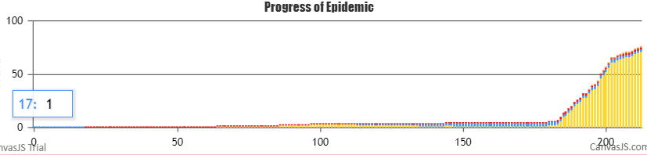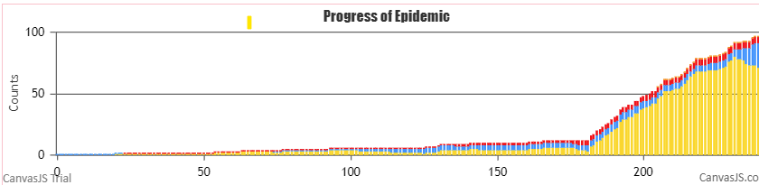

These parameter changes might reflect in HzR increasing, the discarding of masks and social distancing, while with mingle factor increases, the correspondence might be to more crowded spaces and larger groups.

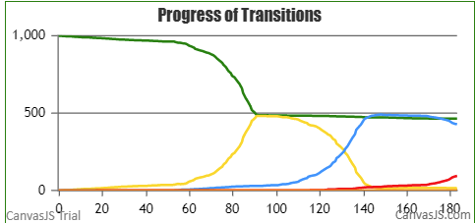When we start with population=1000, HzR=15, mF=2 and decrease these to HzR= and mF=1 we see the results of mitigation as sharp drops in total infections on a daily basis.

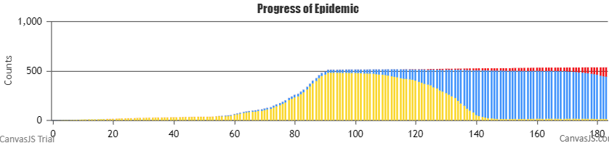

These two charts are slightly different representations of the same data. At gen=90, about half of all the initial susceptibles have been infected, as we see clearly from the green line on the right hand chart. At this point, we intervened to set the HzR to 1 and the mF to 0.1, essentially making everyone not moving, and very small. This would be analogous to extreme quarantine and double masking. The epidemic comes to a halt.

Of course, following the intervention at gen=90, the infected (yellows) already present take the usual time to transform to blue (pre-symptomatic) and then to red (symptomatic). However, since they are frozen in space and negligible in size, there are few further infections.

This is an aggregate view of a single population subject to the same constraints (parameters), and this is approximately how public health is viewing the changes in epidemic numbers, using the mass-effect approach adopted for equation-base data modelling and prediction.

The next scenario involves changes in the virus-human interaction, which may create surges in becoming more infective.

**SCENARIO TWO. CHANGES IN VIRAL TEMPORAL DYNAMICS**

The UK variant of SARS-2-Cov, known as B.1.1.7, was estimated to be 70% “more infective”. The Brazil variant of concern (“VOC”) is now estimated to be 2.3x more infective than the initial Wuhan variant.

We have modelled the UK variant in CovidSIMVL (reference medrxiv.org), by changing the HzR and measuring the time (in generations) that was from 0 to 25 infections, from 25 to 50 infections, and from 50 to 75 infections of a population of 100. The velocity increases were calculated as the difference in generations over the base, in order to obtain “faster than” numbers.

The results can be summarized in these two charts.

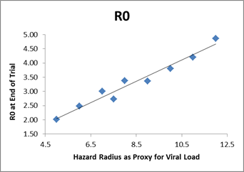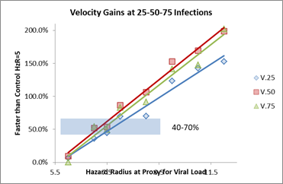

These show that for a 70% faster transmission, the Hazard Radius is in the 7.5 range, and for the 200% (twice as fast) transmission, the Hazard Radius would be in the 12.5 range, derived from the data tabulations shown below.

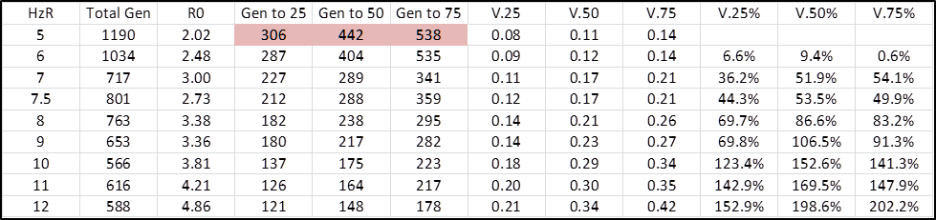

The first scenario shows the surge that results when the HzR is increased suddenly and dramatically, and this can happen without changes in social behavior.

An important consideration is that if the HzR increases from 5 to 12.5 in the case of the P.1 Brazil variant, this is an increase of 2.5 times in the radius. If we use a sphere as the holder of the viral load, the equivalent proportionate is, given the volume of a sphere as 4/3(pi)r^3 and a circle as (pi)r^2, is 4/3r.

This means that the viral load for the P.1 variant is 4/3 x 12.5 = 17 times the usual viral load. If this were the case confirmed by laboratory and clinical results, it could imply a significant change both in the temporal dynamics (shorter incubation periods), as well as impacting the clinical severity and outcomes of infections by the P.1 VOC.

The next two scenarios raise the possibility that aggregate statistics may mask variations in component populations which, if taken in isolation, show surges that are may be purely stochastic. These might be considered to be thought experiments, the implications of which we can model in the simulation sand-box, and the results of which may cause us to think about what and how we aggregate epidemiologic data.

**SCENARIO THREE. THE SIMPLE BUFFER POPULATION**

This is a simple three Universe configuration, in which the first is a Generator, with moderate to high dynamics, the second a buffer Universe, which has slower dynamics, and the third a “canary” universe, which is a high activity environment into which a single infective would cause rapid transmissions throughout.

The population in each Universe is 100, but their interaction is such that the Generator Universe has an initial group of 4 infectives, of which 2 remain, and 2 go along with 8 others from the Generator to the Buffer. This visiting group stays for 6 hrs from 1200 to 1800.

The Buffer Universe sends 10 agents to the Canary Universe, also at 1200 to 1800. The Canary Universe population does not travel, but have high mF and HzR.

The dynamics are that the 2 infectives that remain in the Generator universe create more infectives, among which will in time be some or all of the eight initial susceptibles from Generator to Buffer.

The Buffer Universe receives the initial two infectives from the Generator, but if they infect those in the Buffer, they in turn will be able to infect those who travel to the Canary Universe.

When the Canary Universe receives an infected, it is very likely to transmit within that Universe, since the dynamics were set high. The Canary activation will depend on when one or more of its visitors from its Buffer become infected, and that depends on the internal transmission within Buffer from Generator. However, since Buffer returns agents to Generator, it may be the case that Buffer will supply Generator with new infectives of the set Generator->Buffer agents.

We have created three separate streams A,B and C within a Multiverse to contain three parallel and identical sets of Generator-Buffer-Canary. This is depicted in the diagram below.

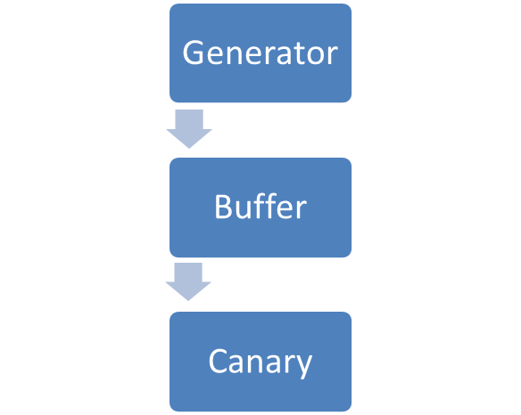



10 susceptibles

2 infected

8 susceptibles

The trials therefore show 3 outcomes for each set of Generator-Buffer-Reactor, but since they are within a Multiverse, we get the aggregate results for the entire population of 900 in the Multiverse.

First, the Multiverse data are shown below (red line=symptomatics; green=susceptibles)

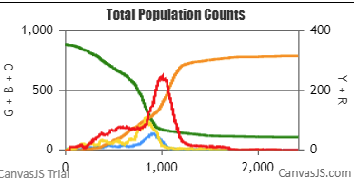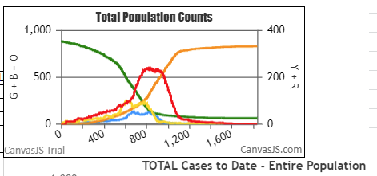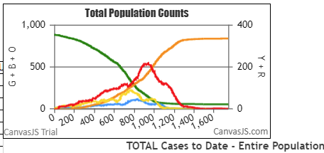

Trial 2 Trial 3 Trial 4

The parameters: HzR 3; mF Canary = 3; mF Buffer 0.1; mf Generator 1.2; sizeFactor Canary 1.3

Size Factor is a parameter that permits local inflation of the size to compensate for the fixed arena, so that sparse cohorts can have a reasonable opportunity to infect or be infected.

However, the same set of parameters also produced the following Multiverse aggregate statistics.

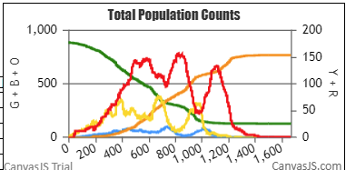

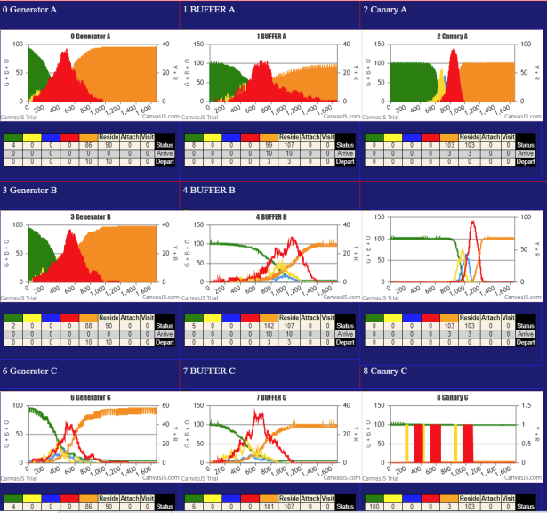Here, we see what can easily be interpreted as one peak with two succeeding surges. Recall that these are the statistics for the entire Multiverse, so that the peaks toward the end reflect what happens toward the end, which may or may not be Canary data. If by chance an infective found its way through the Buffer to Canary early, the Canary population, becoming infected quickly, would contribute to early Multiverse data. The actual timing for this trial is shown in the Multiverse panels below.

The Generators are in the first column, the Buffers in the second column, and the Canaries in the third.

It can be seen that Canary C was not active, and that Canary A and B, given their rapid dynamics, show sharp spikes, but 2oo generations apart. Similarly, Buffer B is delayed with respect to Buffer A and C, and both of them had only 6 susceptibles left.

The Multiverse statistics are composites of their constituent cohorts. However, if one looked at the Canaries from their local point of view, we would have Canary C spared while the other two had intense infections. The origin of the spikes, from the Multiverse point of view alone, cannot easily to attributed to component population stochasticity without detailed knowledge of the component epidemics and their interactions.

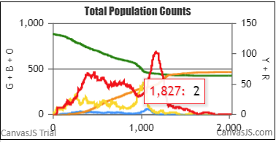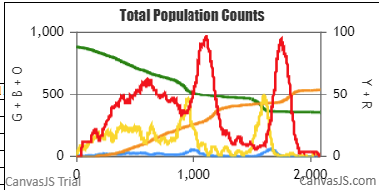Here are three more examples where the Multiverse shows a surge, three with the same set of parameters.

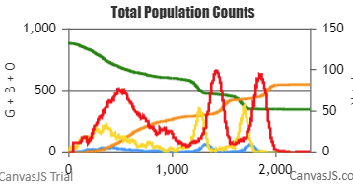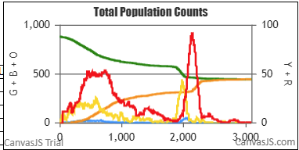

To repeat, these are the aggregate data for nine Universes each, within which there are three independent sets of interacting Universes. The aggregates are counts of all the Universes, so the surges shown here were not the result of changes in parameters, or of the viral temporal model, but purely due to stochastic variation in the chain of transmissions. For the top right chart, the components look like this.

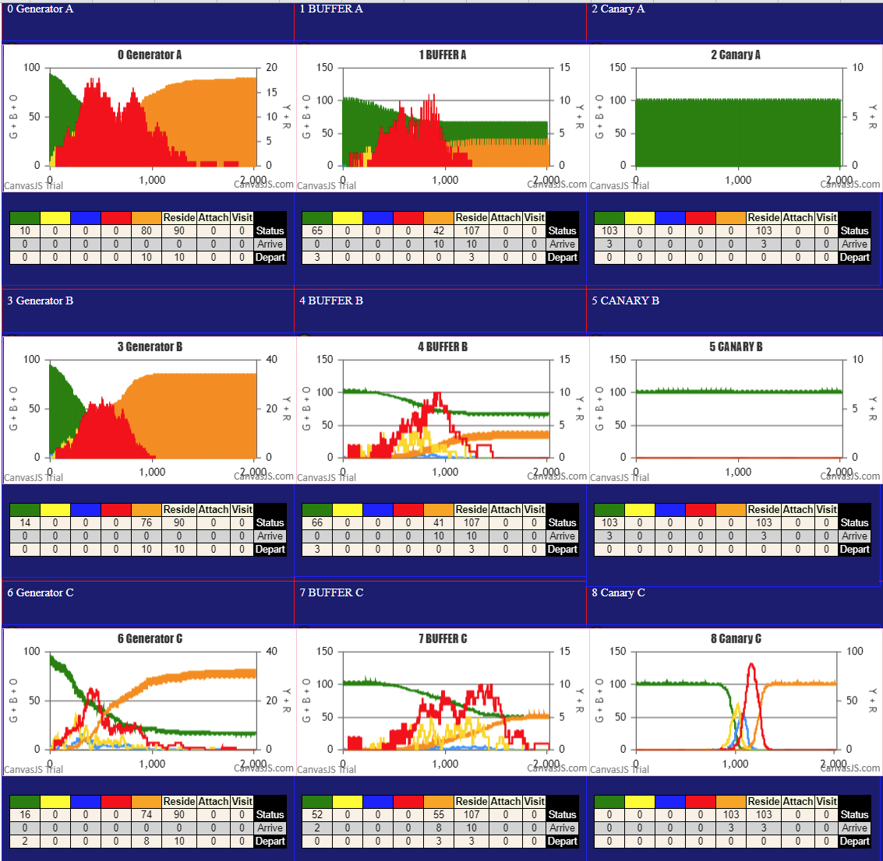

All three Generators have only 10-16 susceptibles who were not infected, but the numbers for Buffers are 52 to 66 uninfected.

Surprisingly, two of the three Canaries were not activated – they had no internal infections that were sustained.

In this case, the surge shown in the Multiverse is due to the high dynamics of Canarie C, at around gen=1200.

Buffer A shows two peaks, Buffer B one, but Buffer C has a protracted peak whose duration goes right to the end, and with a high point around gen 1200, compared to the other two, which had highs before gen=1000.

This variability in the stochastic executions of the epidemic with the same parameters raise three questions: the first is how much we can attribute aggregate data to social and viral causes, rather than to stochastic variation; the second is the question of what epidemic we are experiencing in our context – an average, an outlier, or are all the individual epidemics that occur unique; the third is that of finding the parameters of an epidemic – it the experiences in each context might be quite dissimilar despite common parameters, just because of stochastic variation.

The model that begins to emerge from this thought experiment is that an aggregate data of an epidemic might always be the sum of dissimilar constituent component cohorts, which are not uniformly exposed to the viral pathogen, but have idiosyncratic patterns of movement flow between them, and of potential internal dynamics of mingling and exposure risks within them. As the virus moves to one set of spaces to another, through some probabilistic chain, pockets of populations not previously exposed or not having sustained transmissions can go into active growth, and be reflected by a surge in the aggregate.

We pursue this line of thought in the next thought experiment, which we call the STAR structure.

**SCENARIO FOUR. THE STAR STRUCTURE**

This is a more complex structure involving all nine Universes in one configuration. There is a Generator Universe, and a Mixing Universe, with the seven remaining Universes acting as Villages. The circulation of persons between them is of crucial importance, as they afford examples of two-way interactions.

The Generator gets initial 3 cases, two of which are part of the group of 10 that travel to the Mixing Universe from 1200 to 2000. The other stays behind to infect the rest of the Generator cohort.

The Generator does not just depend on its outbound group, but gets 10 visitors from the Mixing Universe, which like all the Universes, have 100 agents as their base. These leave the Mixing Universe from 0200 to 1000 hours, so that the Generator gets 20 carriers of infection – its own outbound on return, and the inbound from the Mixing Group.

Each of the Villages sends 10 visitors to the Mixing Universe from 1200 to 2000hrs, so the maximum population at the Mixing Universe is 70 (from the Villages) + 10 from the Generator + 100 base in Mixing which totals 180.

What we expect to happen here is that one of the outbound from a Village would be infected when in the Mixing Universe, and that infected agent, on return to the Village,creates a sustained epidemic within that village. What is apparently non-deterministic is whether and when one of the outbound from a Village will be infected from the Mixing Universe.

If the dynamics of the Mixing Universe are set high, then most of the agents that go to the Universe will be infected in time. However, if the Villages have low dynamics, and the infected agents on return are staggered over time, none of them might cause a sustained chain of transmissions within a Village.

If the Generator evolves to a state in which there are no further infectives among its 100, but its outbound group still has susceptibles, then there is a possibility that one of them could be infected in the Mixing Universe, as long as it is still active.

Again, if its native population is not, but there is a Village which continues to have transmissions, they could then infect one of the outbound group of that Village, which would then carry the infection into the Mixing Universe, and possibly infect any Universe which has membership in terms of outbound susceptibles into that Universe.

Thus, we have a system in which the Multiverse continues to run, as long as there is a single Universe which has infectives. Only when the entire Multiverse has no more infectives does the system self-extinguish.

The shape of the Multiverse epidemiologic statistics is determined by the sum total of the 9 Universes at any one point in time. The expectation is not great that the summary dynamic would be seen in the constituent Universes. The extent to which diversity and heterogeneity exists will be seen below.

The following simulations were run with the population traffic as described, and the parameters used were:

HzR 3

size Factor 0.5 Mixing Universe 1

mF 0.5 Mixing Universe 1

mF 2 Generator Universe 0

mF 0.08 Villages 2-8

size Factor 0.6 Villages 2-7

RedDays 11.2 3 days of clinical transmission

These parameters were arrived at by trial and error to produce heterogeneity. If the parameters are set so every Universe is highly dynamic, then the results tend to be more homogeneous and resemble single Bell curves, as in the Particle model (CovidSIMVL, medrxiv.org).

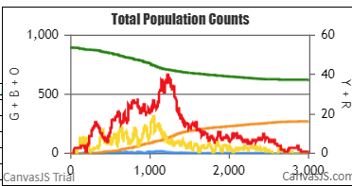***The Multiverse Aggregate Charts with the Tabulated Parameters Above***

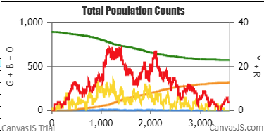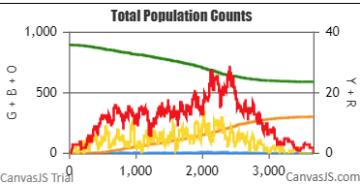Trial 20 Trial 19 Trial 18

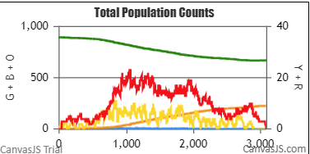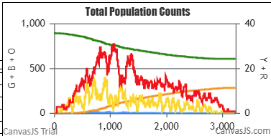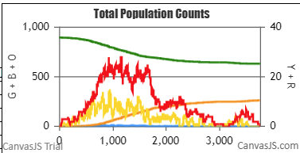Trial 17 Trial 16 Trial 15

These trials are consistent in some ways – the generations are basically op to 3,000 by self-termination, and the remaining uninfected agents number in the 600s, by visual examination of the green lines against the left Y-axis. The count of Reds (clinical symptomatic) reach past the 20s (most of them) to near 40 (top right chart).

Where they differ is when the peaks occur of the Red agents, whether there appear to be surges, and how sustained over time are the plateaus. For example Trial 20 has a broad plateau from gen600 to gen3,000 but with two closely spaced surges. Trial 16 has 3 surges early in its course. Trials 17 and 15 have late surges. Trial 19 has 2 high and well separated surges, the second one resembling many IRL (“In Real Life”) surges over Christmas.

To see what is behind these Multiverse aggregates we can look at a few of the Universes. First, the one for Trial 15, then we can compare it to Trial 19.

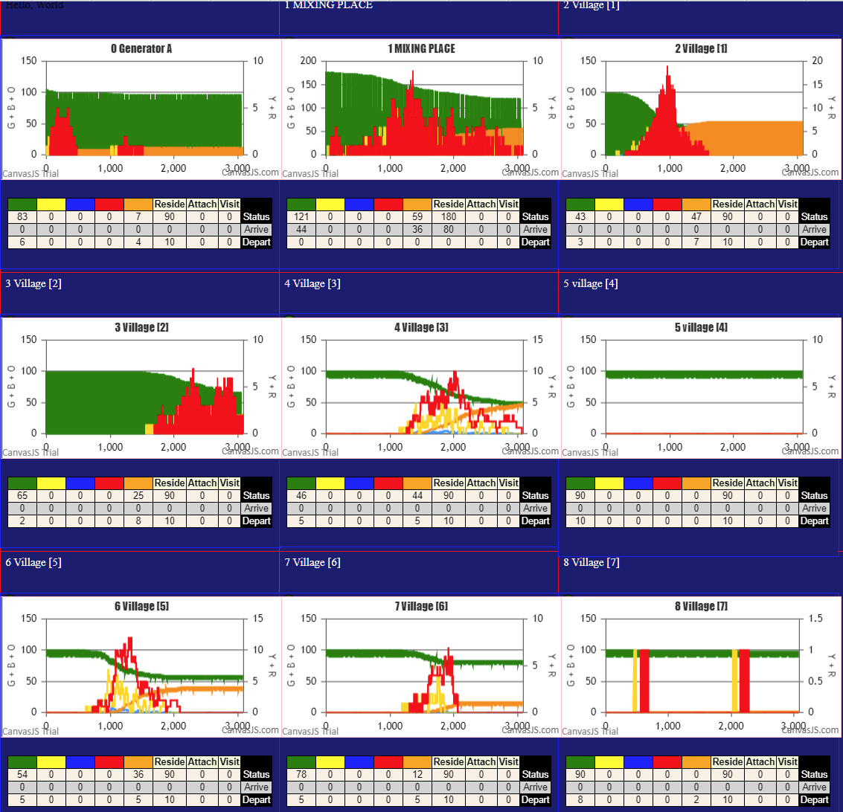In Trial 15, the Generator Universe did not really take off, having 83 remaining susceptibles. Second, the two Villages – 4 and 7, did not have any infections.

Village 1 was experienced its epidemic early, peaking at 1,000 and starting near 100. However, Village 2 and Village 3 had their epidemics late, starting after gen=1000 and continuing to gen3000.

Village 5 and Village 6 are mid-term epidemics, terminating around gen=2000, starting just before or around 1,000.

This is a very mixed set of component epidemics.

Now look at Trial 19, which has two well-defined large surges, a small early surge, and a number of small late surges. Its Universes are shown below.

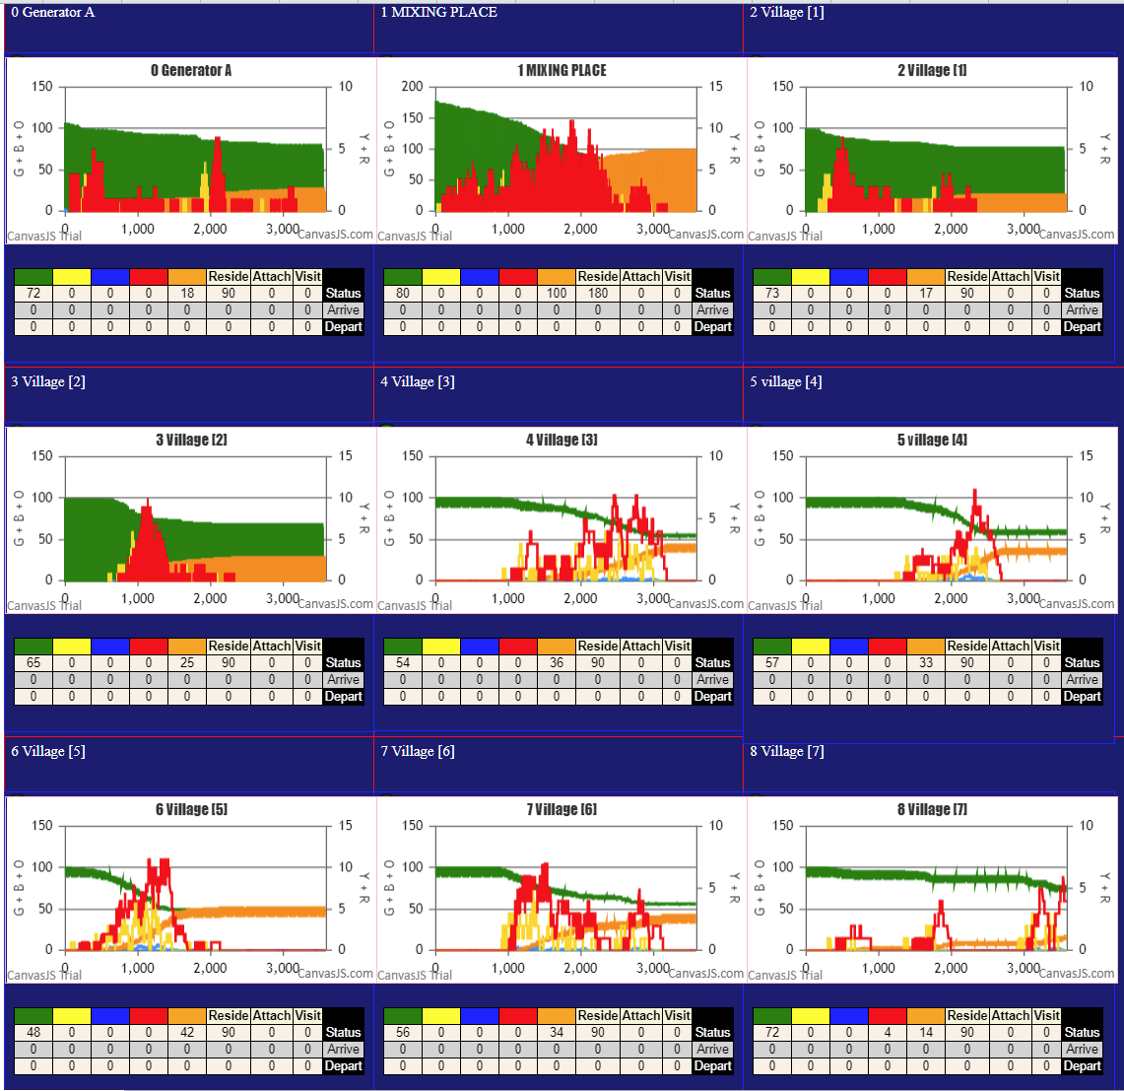Again, the Generator Universe stopped earlier and was less dynamic than we would want of its role.

Village 1 had 73 uninfected at termination, while Village 5 started at the same time, but ended at gen=1000 but with 48 uninfected.

Villages 2,3,4 and 6 all started around gen=1000, with 2 and 4 finishing early, around gen 2500.

Universes 3,4,6 and 7 are remarkable for the number and relative height difference to the valleys, and in Universe 8 the surges are separated by baseline inactivity.

**DISCUSSION**

Not only would it seem difficult to predict the mix of dynamics in these components of the Multiverse aggregates, it would seem also that from the viewpoint of any of the Villages, the others might appear similar for some, and totally dissimilar for others.

Yet these all operate under the same parameters and physical activity models. The indeterminism is the stochastic uncertainty as to which agents move to contact which other agents, and their subsequent moves, which are also stochastic. These are not random moves, but follow a probability distribution, and yet the details within the components can be radically different, while the aggregates share similarities, but are also dissimilar.

In this paper, we have put forward a number of mechanisms through which surges in the daily count of cases in the Covid-19 epidemic might occur. While some of these factors might be behavioral and of social origin, others may relate to the nature of the viral-host interaction, and most intriguing of all, these surges may be simply a result of the probabilistic non-determinism. The envelope of events that may occur due to the movement to and fro of potential carriers travelling between different viral mixing spaces is large, and apparent surges may be simply one of the probable chain of events in a heterogeneous and complex environment with dynamics that may turn on the outcome of a single saddle point.